**SMART HEALTH CARE SYSTEM**



**Group Members:**

**Iqra Muzaffar 2020-CE-45**

**Hooria Azeem 2020-CE-46 Palwasha Zulfiqar 2020-CE-48**

**Client Dr. Asim Rehmat Software Engineering (Lab)**

**Department of Computer Engineering University of Engineering and Technology, Lahore**

**TABLE OF CONTENTS**

1. Design 4
2. User-Interface
   * + Homepage
     + Contact Page
     + Services
     + Appointment
     + Doctor’s Dashboard
     + Patient Dashboard
     + Admin’s Dashboard
3. Database Design 9
4. OCR 12

# DESIGN

Design is an essential part of software development as it provides a way to visualize the end product, ensuring that it is user-friendly and intuitive. Good design can help increase usability and make the user experience more enjoyable. Design also plays an important role in communication, allowing developers to communicate their ideas to stakeholders and other developers. Additionally, good design helps prevent bugs and software errors, as well as allowing for easier maintenance

# The User Interface

The User -interface of our website has 3 dashboards:

1. Admin Dashboard
2. Patient Dashboard
3. Doctor Dashboard

**The Home Page**



**The Contact Page**

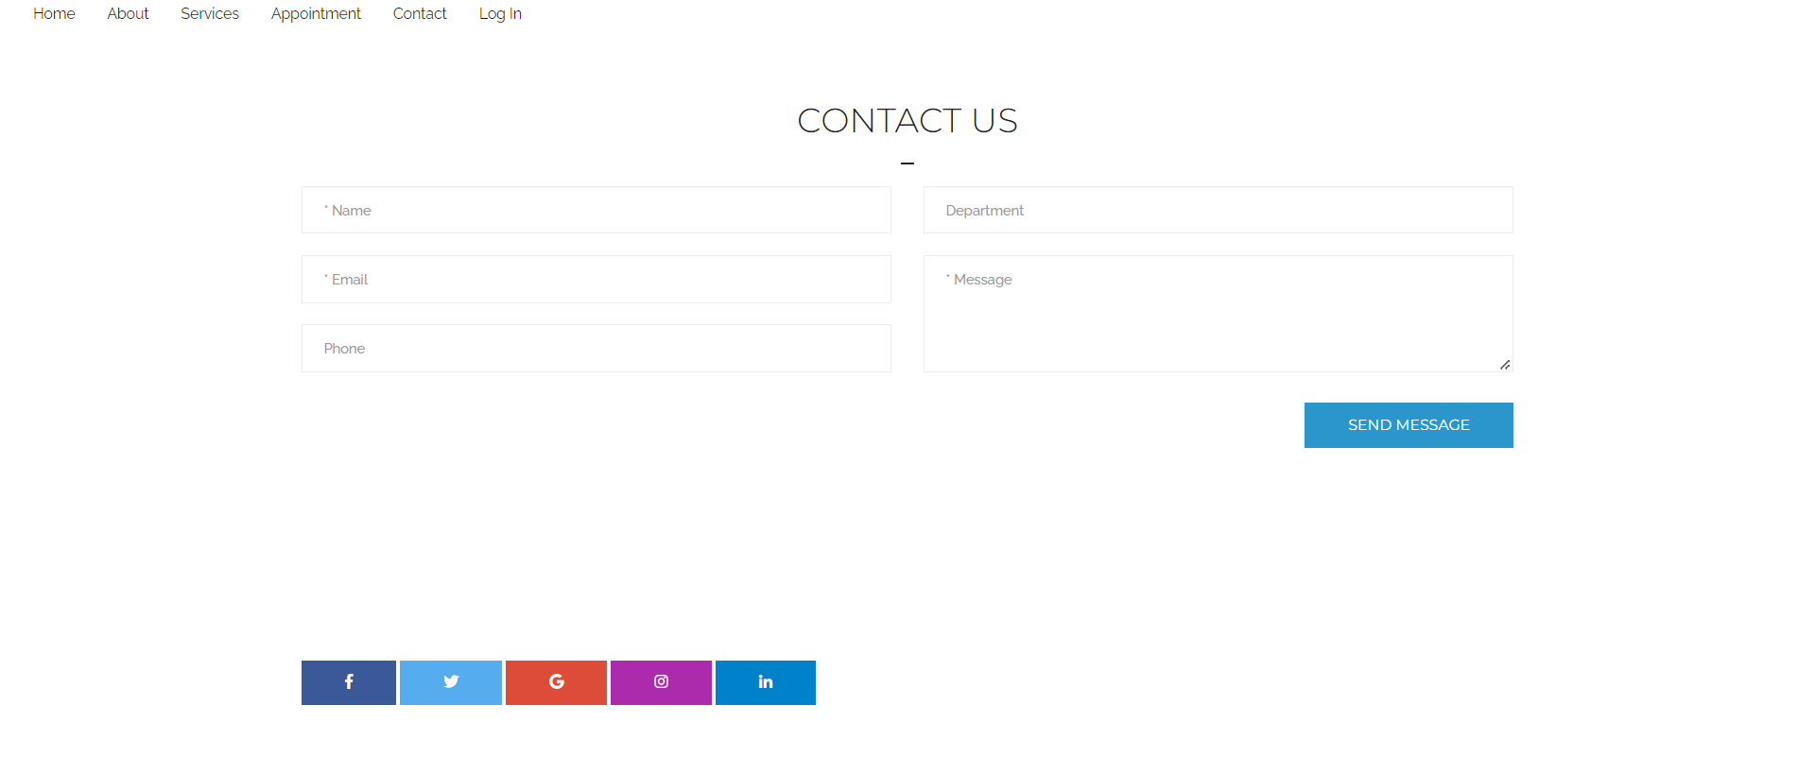

**Services**

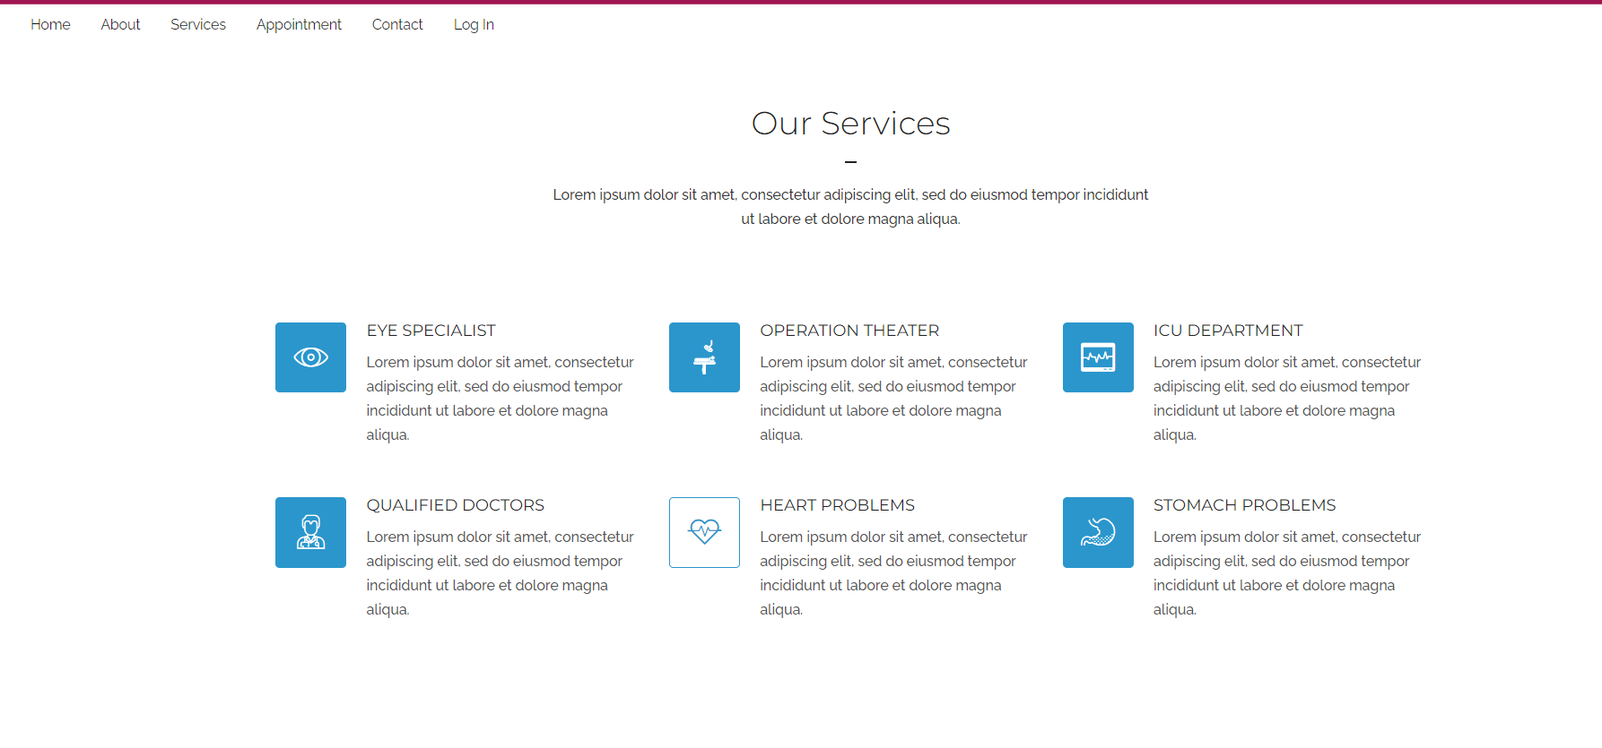

**Appointment**

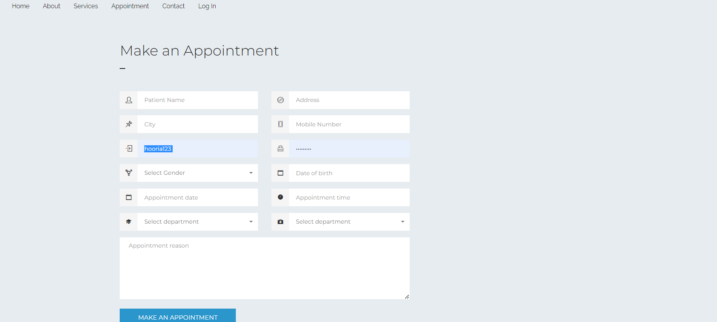

**Doctor’s Dashboard**

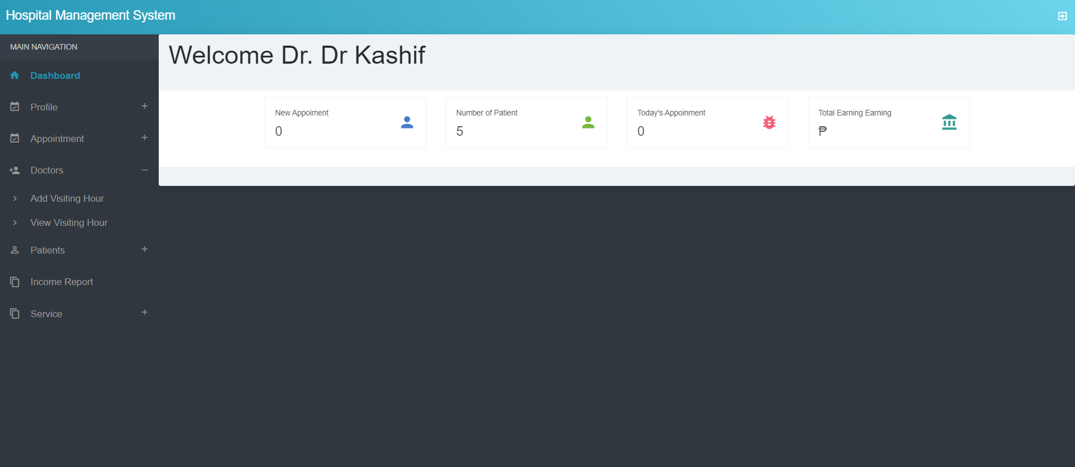

The panel has all the functionalities that the doctor is able to do.

* View profile and change Password
* View and approve pending appointments
* Add and View Visiting hours
* View Patients and advice prescription
* View Treatment records and Income Report
* Logout from the icon on the right-top

**Patient Dashboard**

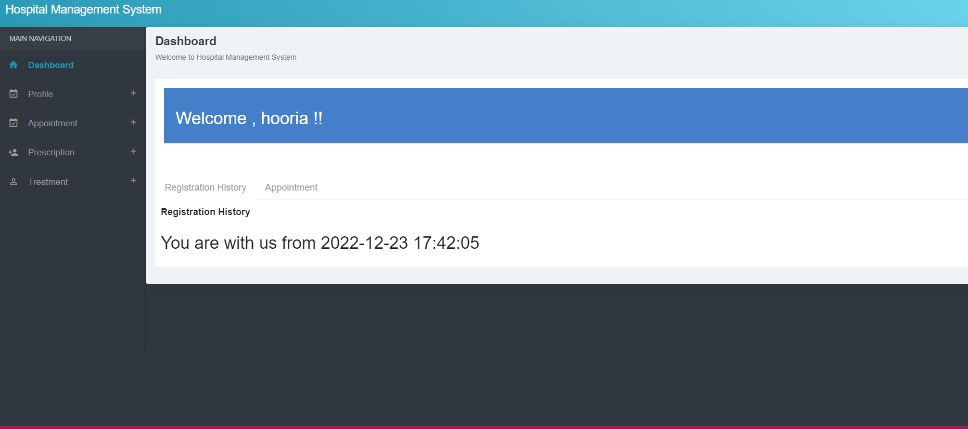

The panel has all the functionalities that the patient is able to do.

* Add and View Appointments
* View Prescription
* View Treatment records
* Logout from the icon on the right-top

**Admin Dashboard**

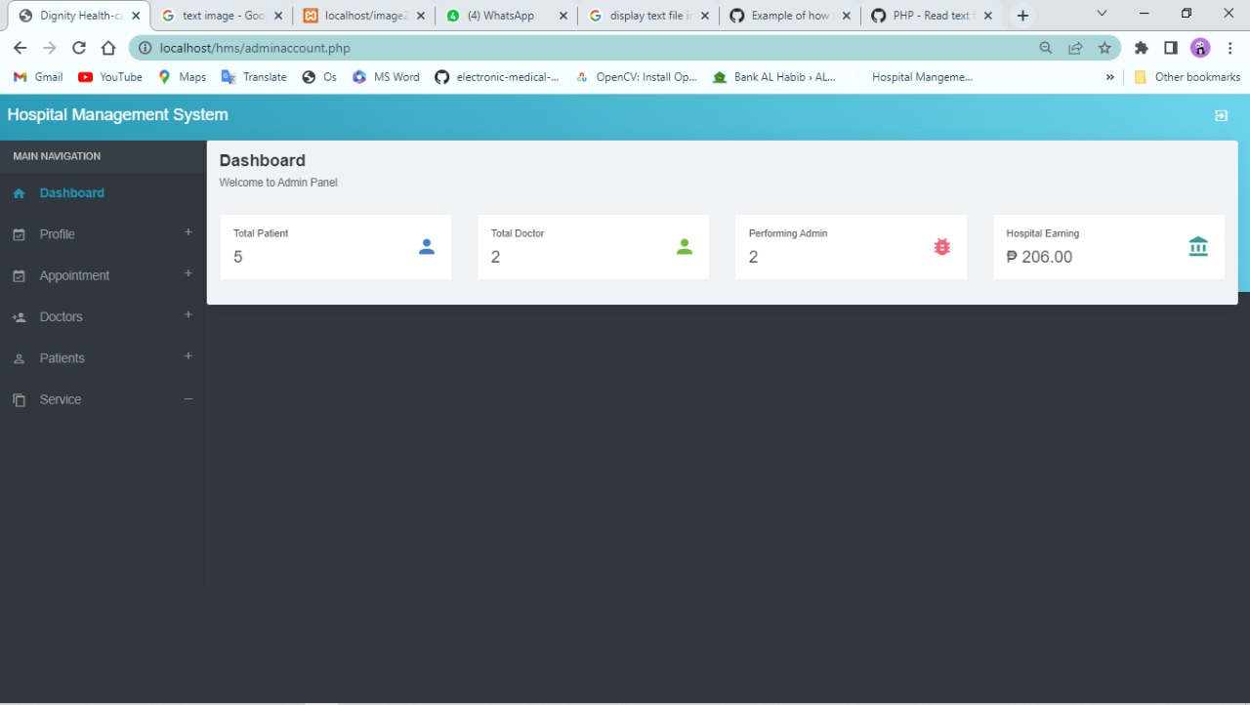

The panel has all the functionalities that the admin is able to do.

* Add and View Appointments
* Add and View Doctors
* Add and View Patients
* Add and View Treatment records
* Add and View Medicine
* Add and View Departments
* Logout from the icon on the right-top

# 2. The Database Design

# 

Our database name is HMS.

We have 18 tables in our database:

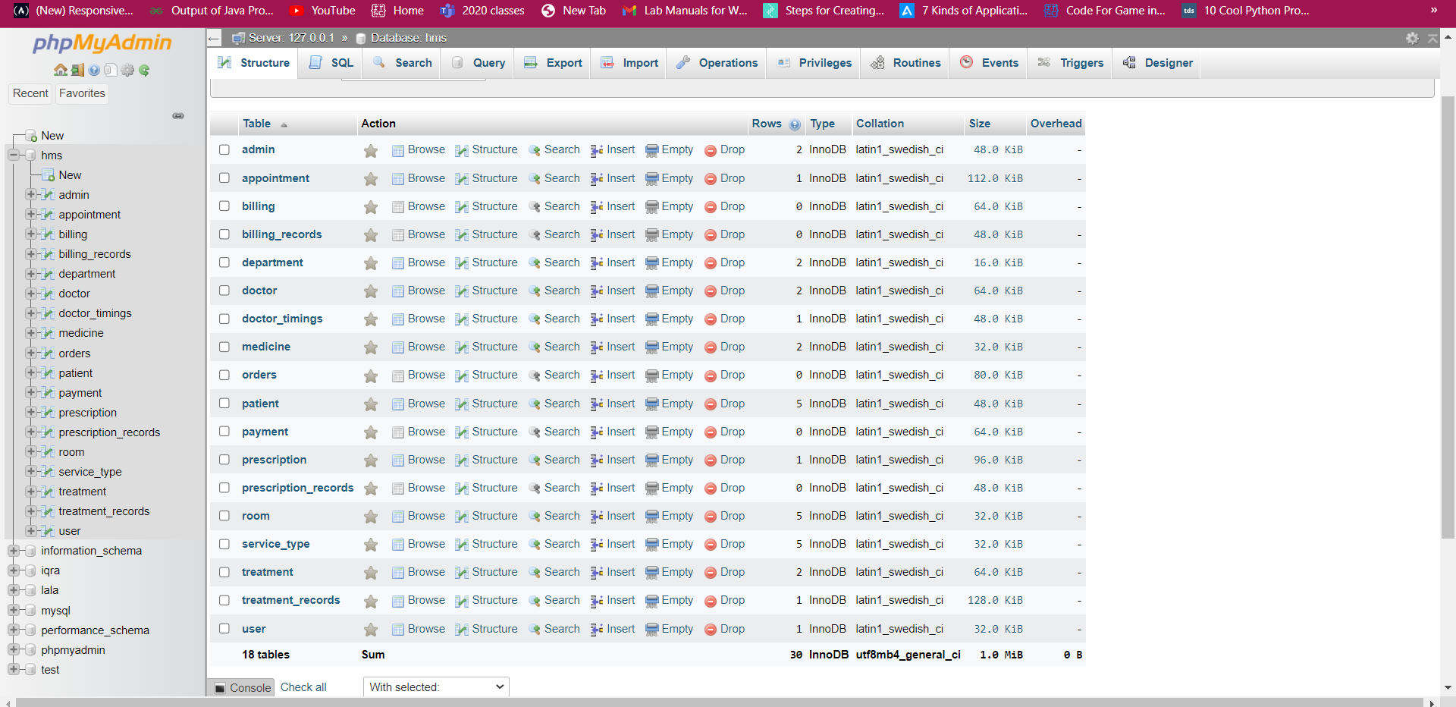

The tables have Records for Admin Information , Doctor Information & Patient Information. It has prescription records, treatment records, services records as well as billing records.

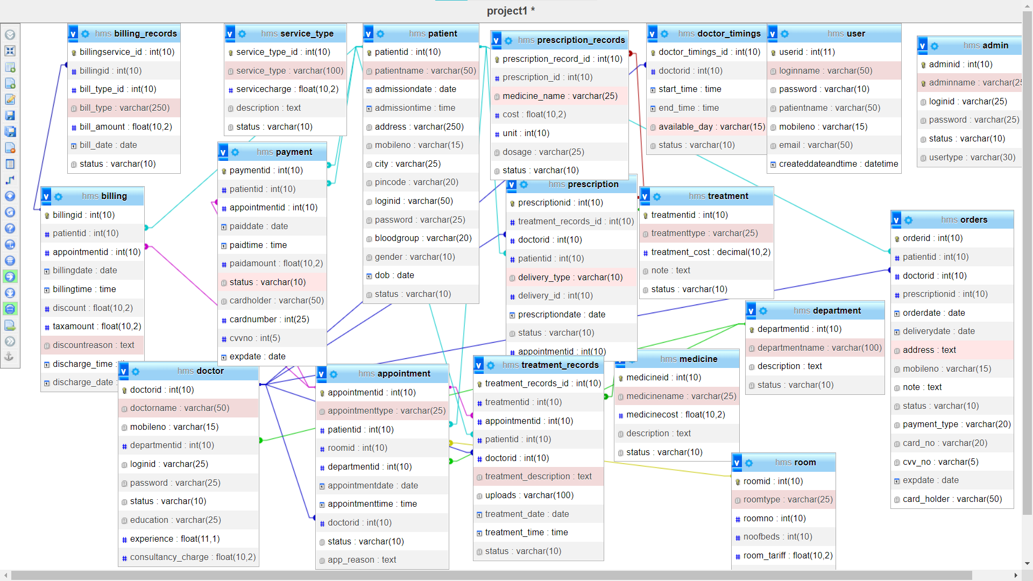.

**The OCR**

**Image**



**Converted Text**

